**Web Page Extra Credit 4: CSS Positioning, Background Images, Tables**

**Prerequisites: Web Page Extra Credit 1, 2 & 3** *links here*

**Starter File:** *link here*

**Files to Submit: ExtraCredit3.html & webpage3.css**

**Points: __**

You may use Visual Studio Code to complete this assignment, just be sure to save your file with the extension .html! After saving and closing the file, you can see your document as a web page by right-clicking on the file, selecting “open with,” and choosing your web browser. To access the html code, right-click on the file and open with Visual Studio Code. (You can also use a basic text editor such as TextEditor or Notepad to create html files, but Visual Studio Code makes the formatting much nicer.)

Begin by completing Lesson 7: CSS Positioning, Lesson 8: Images, and Lesson 9: HTML Tables at Codecademy. If you do not already have an account, you will be prompted to create one. <https://www.codecademy.com/learn/learn-html-css>

Download and extract the starter file. Manipulate the web page by completing the following tasks:

1. Add the last row of April calendar. Add a lecture at 9:35am and a lab at 2:45pm on Tuesday, April 29. Then, add a project due at 5pm on Wednesday, April 30.
2. Move the navigation menu down 170 pt. Using relative position, move the table so that it is to the right of the navigation menu.
3. Add the background image cs.jpg (in the provided folder) behind the main heading. Set the position to “center-center” and the size to “cover.”

When you are finished, the web page should look like this:

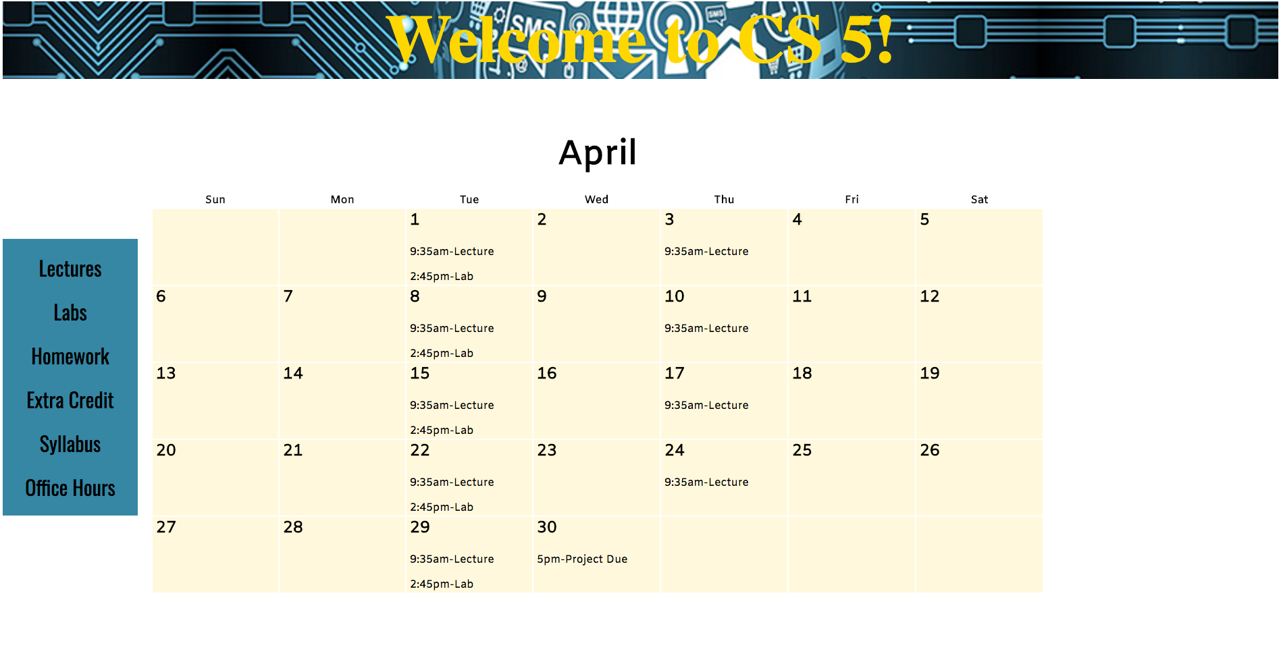

**Additional Resources**

Each Codecademy lesson has external resources in the dropdown menu that review or advance the material covered in the lesson. Feel free to browse this information!